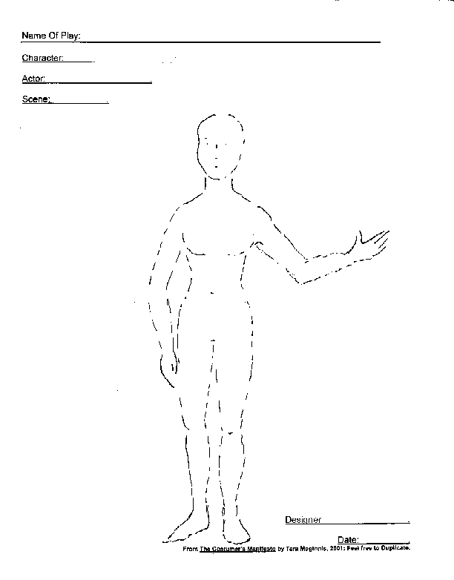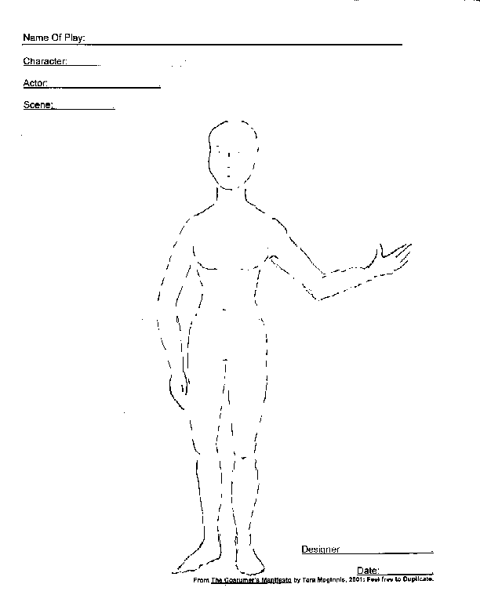

The art of “slamming” a rough draft onto a piece of paper quickly without judgement on yourself. You may include notes about the color, fabric, texture, or where you would get the pieces if you’d wish. The main goal of SLAM DESIGN is to get ideas out.

SLAM DESIGN!

