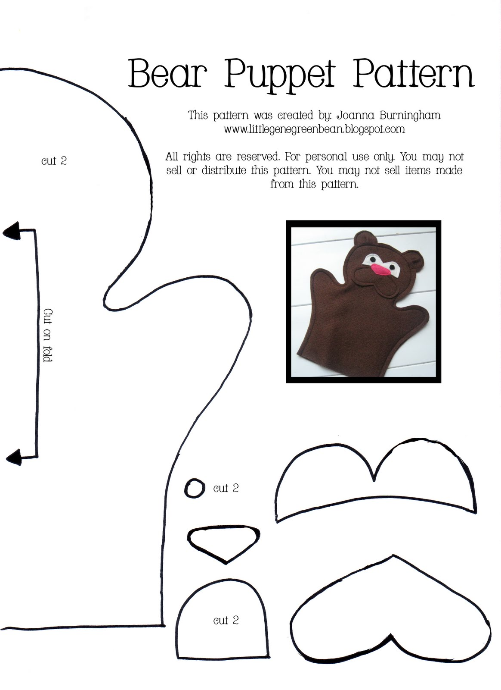

(You can use seam tape, hot glue or fabric glue instead. Glue the two BAD sides together. Make sure you let it dry completely before the next step.)

Step 3. Carefully turn the puppet inside out. (If you used glue, you might want to skip this step.)

Step 4 Add clothes, a face, eyes etc. Decorate it using anything you have.

You can use buttons, doll clothes, pipe cleaners, toys, markers, paint, fabric, paper, yarn, or anything else you find around your house! Be creative.

Step 5. Bring your puppet to class on the due date, _________________.

Step 1. Use the pattern to the left to cut out the front and back pieces of your puppet. (Cut 2.)

Step 2. Put the two GOOD sides of the fabric together and sew the very edge of the puppet all the way around, but don’t sew the bottom. You need to leave that open for your hand to fit through.

Puppet Project!